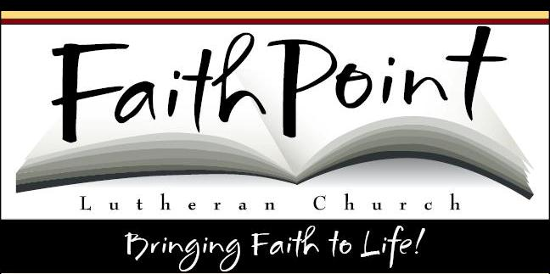
CONFIRMATION
MEMORY WORK
2017-18

October 11, 2017
Jesus answered, “I am the WAY and the TRUTH and the LIFE. No one comes to the Father except through Me.” John 14:6

October 25, 2017
Again Jesus spoke to them, saying, “I am the light of the world. Whoever follows Me will not walk in darkness, but will have the light of life.” John 8:12

November 1, 2017
The First Commandment
You shall have no other gods before Me.

What does this mean?
We are to fear, love, and trust God above anything else.

November 8, 2017
The Second Commandment
You shall not take the name of the Lord your God in vain.

What does this mean?
We are to fear and love God so that we do not use His name superstitiously, or use it to curse, swear, lie or deceive, but call on Him in prayer, praise and thanksgiving.

November 15, 2017

The Third Commandment

Remember the Sabbath day, to keep it holy.

What does this mean?

We are to fear and love God so that we do not neglect His Word and the preaching of it, but regard it as holy and gladly hear and learn it.

November 29, 2017

The Fourth Commandment

Honor your father and your mother.

What does this mean?

We are to fear and love God so that we do not despise or anger our parents and others in authority, but respect, obey, love and serve them.

December 6, 2017

The Fifth Commandment

You shall not kill.

What does this mean?

We are to fear and love God so that we do not hurt our neighbor in any way, but help him in all his physical needs.

December 13, 2017

The Sixth Commandment

You shall not commit adultery.

What does this mean?

We are to fear and love God so that in matters of sex our words and conduct are pure and honorable, and husband and wife love and respect each other.

January 3, 2018

The Seventh Commandment

You shall not steal.

What does this mean?

We are to fear and love God so that we do not take our neighbor’s money or property, or get them in any dishonest way, but help him to improve and protect his property and means of making a living.

January 10, 2018

The Eighth Commandment

You shall not give false witness against your neighbor.

What does this mean?

We are to fear and love God so that we do not betray, slander, or lie about our neighbor, but defend him, speak well of him, and explain his actions in the kindest way.

January 17, 2018

The Ninth Commandment

You shall not covet your neighbor’s house.

The Tenth Commandment

You shall not covet your neighbor’s wife, or his manservant, or his maidservant, or his cattle, or anything that is your neighbor’s.

What does this mean?

(Explain in your own words) We are to fear and love God so that we do not desire to get our neighbor’s possessions by scheming, or by pretending to have a right to them, but always help him keep what is his. Also, that we do not tempt or coax away from our neighbor his wife or his workers, but encourage them to remain loyal.

January 24, 2018
Do not be anxious about anything, but in everything, by prayer and petition, with thanksgiving, present your requests to God. Philippians 4:6

January 31, 2018
…but God shows His love for us in that while we were still sinners, Christ died for us. Romans 5:8

February 7, 2018
Love the LORD YOUR GOD with all your heart and with all your soul and with all your strength and with all your mind; and Love YOUR NEIGHBOR as yourself. Luke 10:27

April 4, 2018- Make up Memory Work
April 11, 2018- Make up Memory Work
April 18, 2018- Service Project

